**COMMENTARY SANDBOX Project Punch List**

1. ~~The COMMENT pane should be renamed NOTES~~
2. ~~The ACTIVITY pane should be renamed VOCABULARY~~
3. ~~User needs an easy way to enter text / HTML into the new NOTES and VOCABULARY panes. This information will need to be different for each page. Therefore need an editor that will allow user to add information to NOTES and VOCABULARY tabs for each page. This must be a user-friendly solution (i.e. NOTES and VOCABULARY fields could appear below the Text field on the EDIT PAGE page in the Wordpress admin area. Ideally code (javascript, CSS, etc.) should be able to be added to these fields.~~
4. ~~The DISCUSS tab (appears along bottom when window is small enough that 3 full columns (CONTENT / TEXT/ Tabs) cannot fit) should be renamed COMMENTARY~~
5. ~~Disable the automatically generated paragraph marks (¶) to the left of text. Text entered into a page should appear as is (or as formatted using HTML) without additional, automatic markup~~
6. ~~Disable the comment bubbles / numbers to the right of text. The commentary infrastructure might be redeployed later, so do not strip it out; but it should be invisible.~~
7. **In “Special Pages”: “Site Home Page” should be renamed “Commentary Library”; like should point to** [**http://iris.haverford.edu/library**](http://iris.haverford.edu/library)**. This should appear by default in as a link at the top of the Table of Contents**

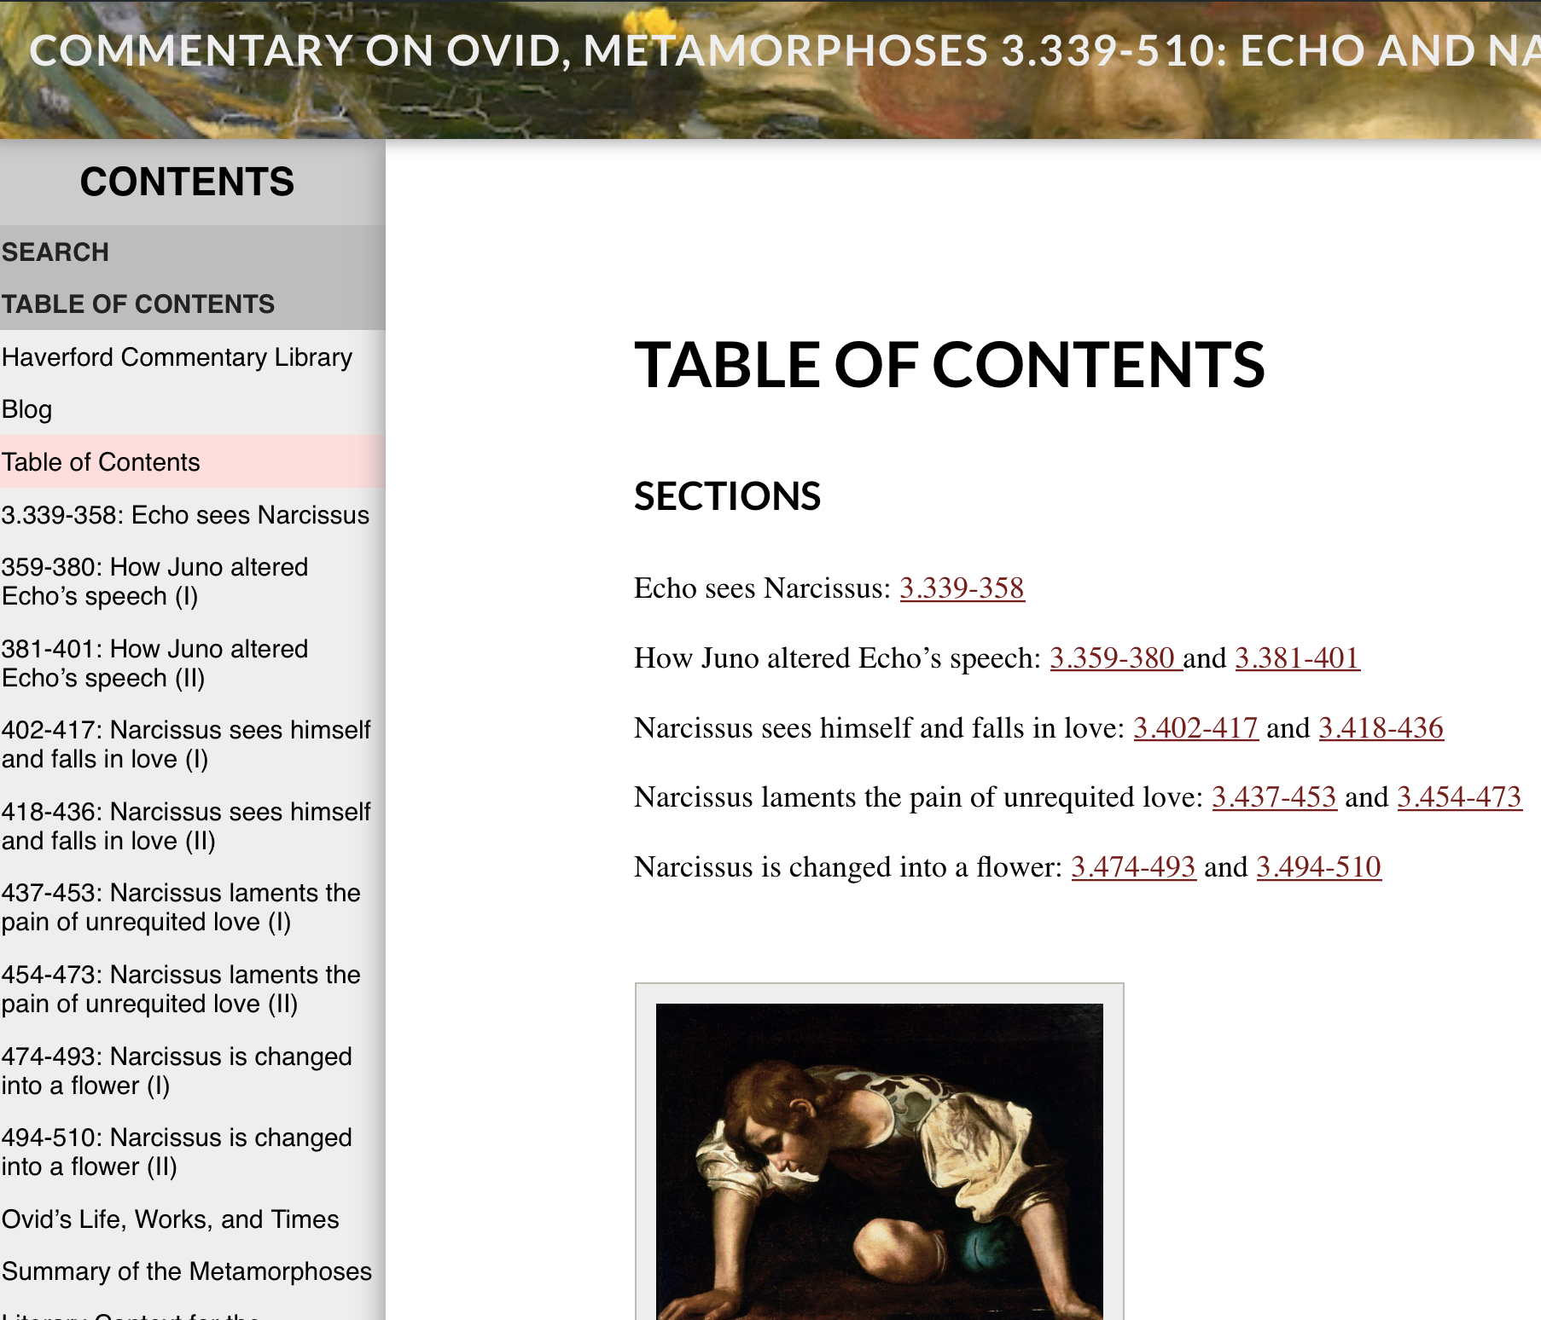

~~See Sandbox Mockup.pdf for samples of what the revised theme should look like.~~

**SANDBOX Project Punch List — PHASE 2**

1. Add Notes and Vocabulary as default entries in Custom Field Drop-down List
2. Can the other custom types in the dropdown menu be commented out for now, so that only Notes and Vocabulary appear in the dropdown menu?

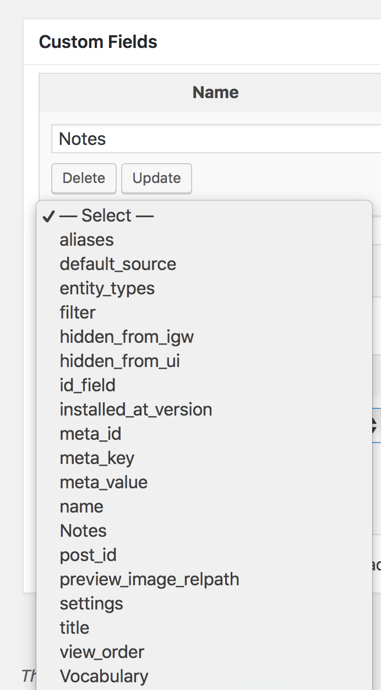

1. Can the default font for the main text be changed to Cardo?
2. The default font size in Vocabulary pane should be a little smaller, so that it matches main text. Note: the font can stay the same (sans serif). I would like the font for the main text to be serif (Cardo if possible) while the fonts for the Table of Contents, Vocabulary, and Notes should be sans serif. The current font for the Table of Contents and Vocabulary = fine.
3. The default font in the Notes pane should be the same as in the Vocabulary Pane
4. A buffer should be added to the bottom of the Notes and Vocabulary panes so that the last line of text is fully visible.
5. Change text on default title page (I will provide text)

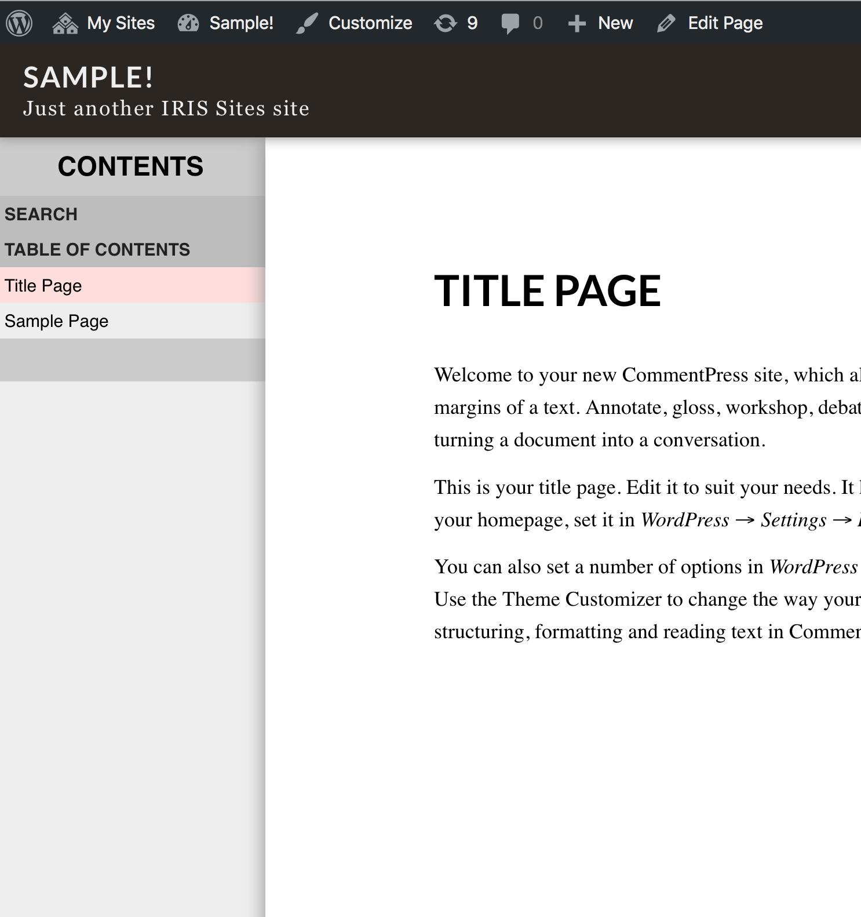

1. Update development information for plug-in
2. In general, when it says “CommentPress Core” we should change it to “CommentarySandbox on CommentPress Core”.

So, for the “Settings” page in Plugins… the Header should be changed. This should also be changed in the dashboard sidebar.

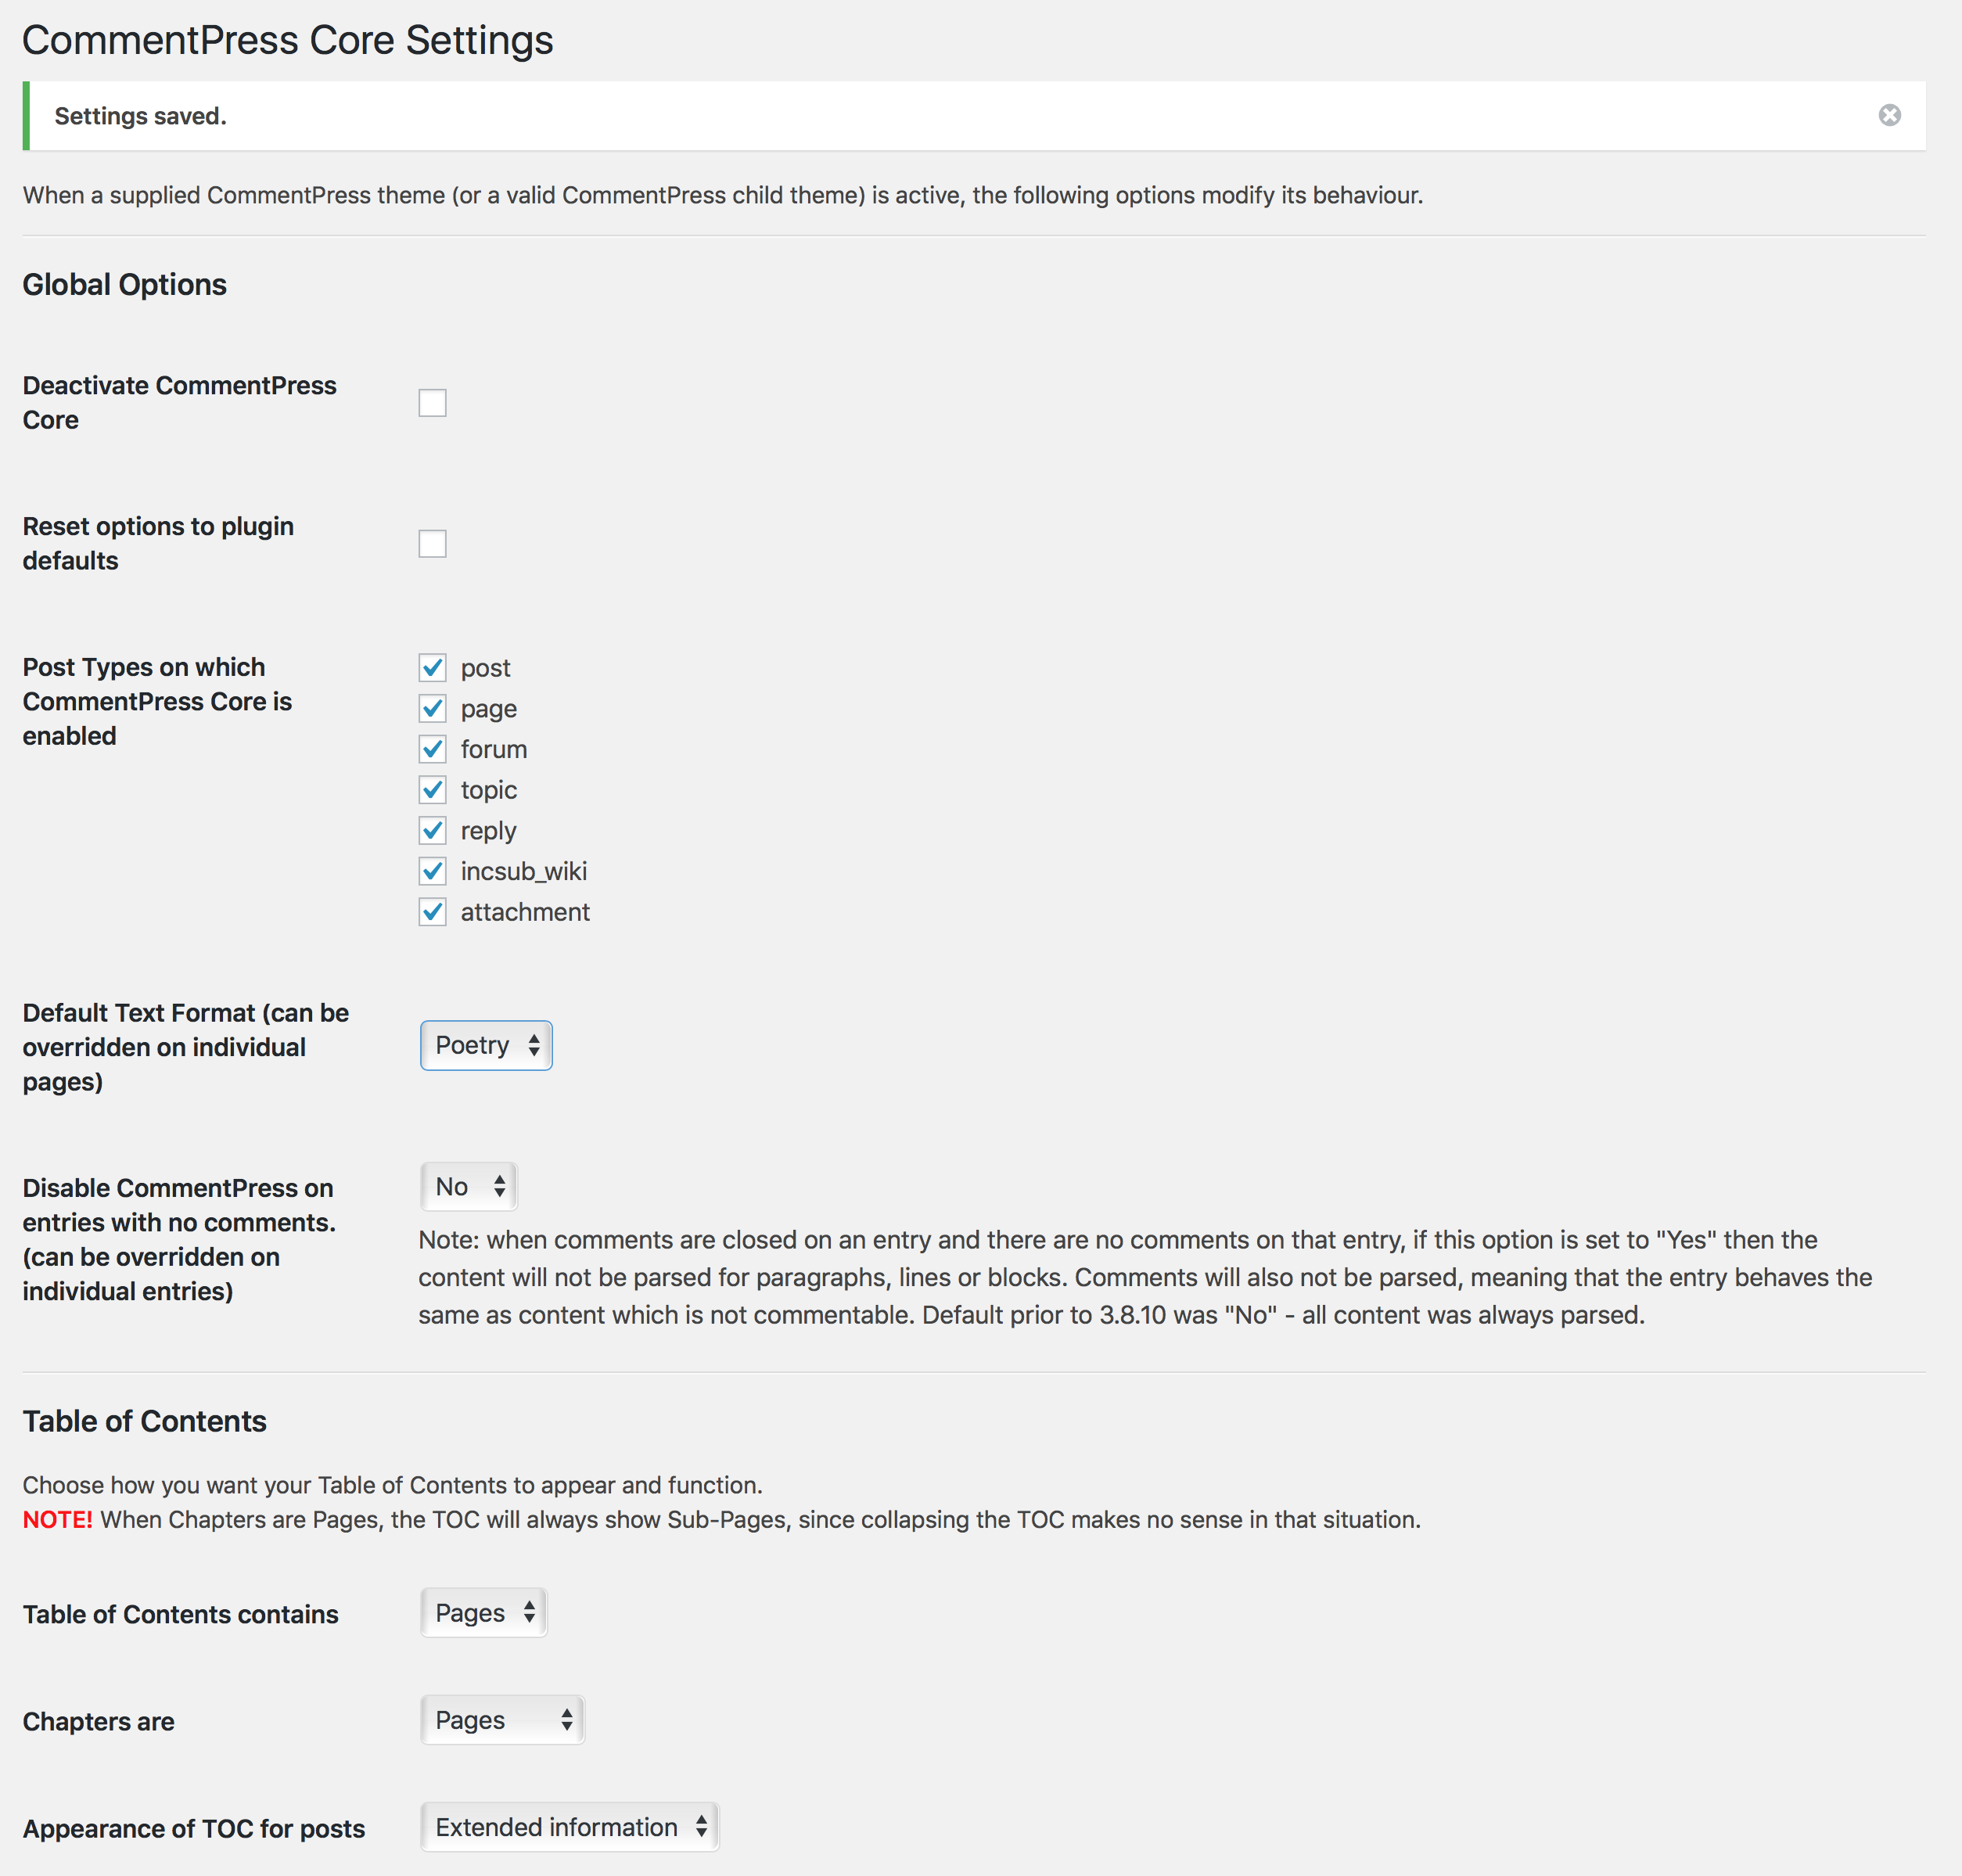

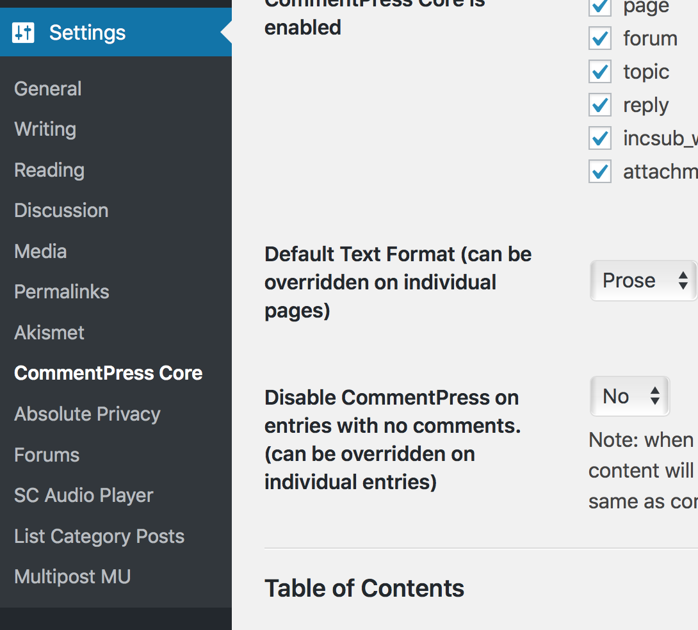

1. When it activates, the “Activate CommentPress” should say “Activate CommentarySandbox”; also “Deactive Commentpress Core” should say “Deactivate CommentarySandbox”

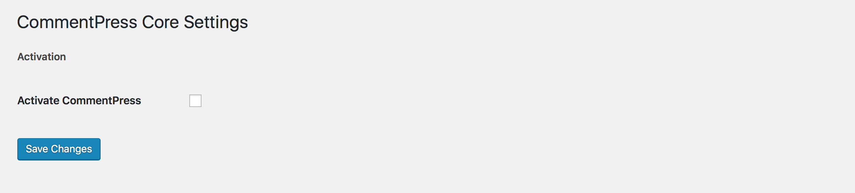

1. In the description on the plugin page, the description should read: “CommentarySandbox” is a modification of the [CommentPress plugin](http://www.futureofthebook.org/commentpress/) by the Institute for the [Future of the Book](http://www.futureofthebook.org/). It allows users to create a simple [DCC](http://dcc.dickinson.edu/)-style digital commentary. Version 1.0 | By Bret Mulligan

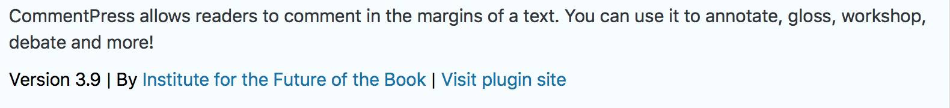

1. Remove the Donate! Link.



1. In general, I’d like to look at the code to see where the CommentPress is mentioned. We need to indicate that the plug-in is built from CommentPress in line with their Open Source License but all credit for their work must be given.
   1. BRET will compose and send for inclusion in CODE.
2. Update documentation, as needed.

**SANDBOX Project Punch List — PHASE 3**

1. Create WSIWYG editing of Notes and Vocabulary Custom Fields

**SANDBOX Project Punch List — PHASE 4**

1. These changes must be packaged as an installable Wordpress Plugin available via the Wordpress directory. The plugin should named “CommentPress Sandbox”